HDC Switch – CGEA1.3

Functional Description

This spec is now obsolete. Please refer to the “HDC Switch or Trail Control Switch IO – CGEA1.3” STSS for HDC switch input processing.

The purpose of the HDC Switch is to allow the customer to toggle the state of the Hill Descent Control system.

The HILL_DESC_SW signal correlates the hardwired HDC switch state and the Operational_Mode to inform the HDC Controlling ECU of the state of the HDC switch.

This implementation of this HDC Switch function is for those HDC systems where the cluster senses the HDC Switch and reports the state of the switch to the HDC ECU via a CAN signal. It is the responsibility of the HDC ECU to determine the state of the HDC system and determine the state of HDC telltales or warnings.

Interfaces

Interface Context Diagram (I/O Block Diagram)
- HDC Switch Interface Context Diagram

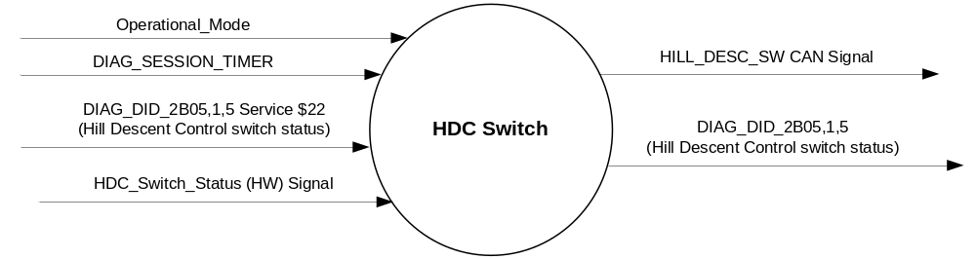

Inputs

      - INTERNAL:
            - DIAG_SESSION_TIMER
            - Operational_Mode
            - DIAG_DID_2B05,1,5 (Hill Descent Control switch status)
      - HDC_Switch_Status (HW) Signal:
1. To be sensed by a micro A/D input port or Digital port
2. Sensing circuit to sink a minimum current of 7 mAmps at 13.25 Volts thru the HDC switch.
3. To have 0 to 50 ohm input under all operating voltage conditions to be closed, which relates to a Press of the HDC Switch.
4. HDC switch will be closed to ground when pressed.
HDC  Switch Condition | HDC  Switch Logic | HDC  Switch Input | Debounce | HDC_Switch_Status
Not Pressed | Open | >50 ohms | 5 samples in a row @10 ms  or 6 samples in a row @8 ms | 0X1 (Not Pressed)
Pressed | Closed | =< 50 ohms | 5 samples in a row @10 ms  or 6 samples in a row @8 ms | 0X0 (Pressed)

Outputs
- DIAG_DID_2B05,1,5 (Hill Descent Control switch status)
- Mux Message on the CAN network

- DrvSlipCtlMde_B_Rq Signal
Signal Name | Size  (bits) | Pos.  (bit) | Detail | Units | Res. | Offset | State  Encoded | Min. | Max.
HILL_DESC_SW | 1 | 33 |  | SED | 1 | 0 |  | 0  (0x0) | 1 (0x1)
 |  |  | Off |  |  |  | 0x0
 |  |  | On |  |  |  | 0x1

Function/Performance

Operational Modes

Mode | Differentiating Vehicle Conditions
Sleep Mode | No sensing of Switch
Limited Mode | No sensing of Switch
Normal Mode | Sensing of Switch
Crank Mode | Sensing of Switch

Voltage Levels

Refer to the Cluster Features table located in the Operational Modes and Voltage Range Strategies Section in this SPSS

Human-Machine Interface

Visual

Indicator Graphics / Display Format
None

Indicator Color Coordinates

N/A

Indicator Characteristics

N/A

Audio

None.

System Accuracy

The output of the state matrix, reference 1.3.5.1 Subsystem Algorithm Flowchart/ State Diagram, shall occur
within 100msec of a state change.

Operation: Performance and Functional

Subsystem Algorithm Flowchart / State Diagram

- State Matrix for HDC Switch
Operational_  Mode | HDC_  SWITCH_STATUS | HILL_DESC_SW CAN Signal | DIAG_DID_2B05,1,5 (Hill Descent Control switch status)
Normal or Crank | 0x0 (Pressed)  / GND | 0x1 (ON) | 0x1 (Active)
Normal or Crank | 0x1 (Not Pressed)  / OPEN | 0x0 (OFF) | 0x0 (Inactive)
All other cases |  | 0x0 (OFF) | 0x0 (Inactive)

Operation Description (supports algorithm flowchart /state diagram)

Function Safety Classification (EMC)

B

Memory Storage

Parameter Name | Description | Value at  Battery Connect | Value at  Module Wake-up
HDC_Switch_Status | Indicates the state of the HW Switch input | Not Pressed (0x1) | Not Pressed (0x1)
HILL_DESC_SW CAN signal | CAN signal output | Off (0x0) | Off (0x0)
DIAG_DID_2B05,1,5 (Hill Descent Control switch status) | Hill Descent Control, byte 1, bit 5 | Inactive (0x0) | Inactive (0x0)
Operational_Mode | 4 state indicator for cluster operational mode | Limited | Limited, Normal or Crank

Parameter Name | Description | Value at  Battery Connect | Value at  Module Wake-up
DIAG_SESSION_TIMER | Timer used to time-out a diagnostic session | Inactive | Inactive

Prove Out
No

Reconfigurable Telltale
No.

Message Center Msg
No.

Error Handling

Missing Message Strategy

The signals will be declared missing as per the Diagnostics section of this SPSS.

DTCs states and history will be determined as per the Diagnostics section of this SPSS.

Diagnostics

Self Test

None

Engineering Test Mode

Reference section “Dealer / Engineering Test Mode (ETM)”.

Part II Performance

Supported Diagnostic DIDs (Service $22)
Number | DID / CommonID Name | DID Type
2B05 | DIAG_DID_2B05,1,5 (Hill Descent Control switch status) | Bit Mapped

Supported Diagnostic Trouble Codes (DTCs)
DTC | Description

Reference Specification

IS-0052 OPERATING VOLTAGES - FUNCTIONAL/PERFORMANCE
IS-0069 FUNCTIONAL IMPORTANCE CLASS

03-0661 PLACEMENT: CONTROL AND DISPLAY LOCATIONS
03-0662 PLACEMENT: LOGICAL GROUPING FUNCTION AND USAGE
03-0664 PLACEMENT: DOWN VISION TO COMPONENTS WITH HIGH VISUAL DEMAND
03-0665 PLACEMENT: EXPECTED LOCATIONS OF CONTROLS AND DISPLAYS VDS
03-0670 INTERIOR VISIBILITY
03-0671 INTERIOR VISIBILITY: REFLECTIONS FROM COMPONENTS & SURFACES
03-0672 INTERIOR VISIBILITY: REFLECTIONS IN DISPLAYS
03-0673 INTERIOR VISIBILITY: VISUAL OBSCURATIONS
03-0674 INTERIOR VISIBILITY: ILLUMINATION CONTROLS / DISPLAYS
03-0675 INTERIOR VISIBILITY: VEILING GLARE
03-0677 INTERIOR VISIBILITY: SUNLIGHT WASHOUT
03-0681 IDENTIFICATION: CHARACTER AND SYMBOL SIZE
03-0682 IDENTIFICATION: LEGIBILITY
03-0685 IDENTIFICATION: SYMBOLS, ABBREV FOR CONTROL
03-0721 LOGIC OF OPERATION: OPERATIONAL STEREOTYPES
03-0722 LOGIC OF OPERATION: INTERPRETATION
03-0723 LOGIC OF OPERATION: USE OF SYSTEMS WITH VISUAL DISPLAYS
EC-0128 SWITCH CONTACT RESISTANCE

Revision History

SPSS Module Revision History

Revision Level | Name | Change Description | Date
1.0 | V.Patel | Updated for CGEA 1.3 based on CGEA STSS v1.2  Section 1.2.2 – Removed tables referencing the HS-CAN messages that contain the input and output signals.  Section 1.4 – Rewritten. Deleted references of specific missing message flags and timer.  Section 1.5.3 – Deleted DTC logging criteria from table. | 4/7/2010
1.1 | S. Watkins  M. Hakim | Removed LED output drive throughout the document, since the cluster no longer supports this feature.  Removed DrvHdcLampInfo_D_Rq signal throughout the document, since the LED drive functionality is removed.  Removed the missing message DTC from section 1.5.3  Section 1.3.5.1  Added table row for “All other cases”  Section 1.5.3  Removed Service $2F from supported diagnostics  Updated document footer | 8/9/2013
1.2 | Vpatel7 | Obsoleted the spec | 1/31/2017

